Mantid
PM report to Project Management Board
22nd January 2016
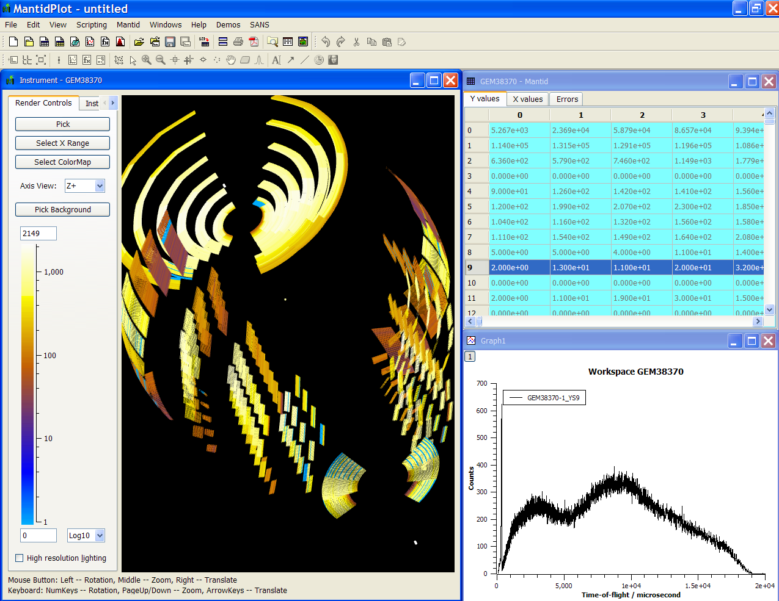
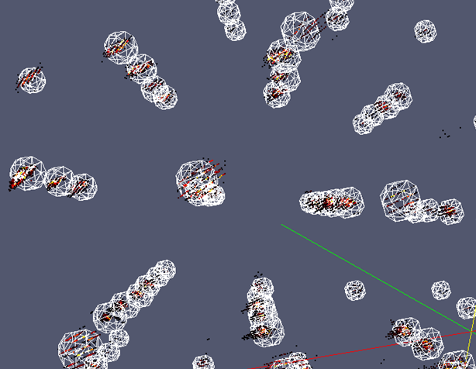
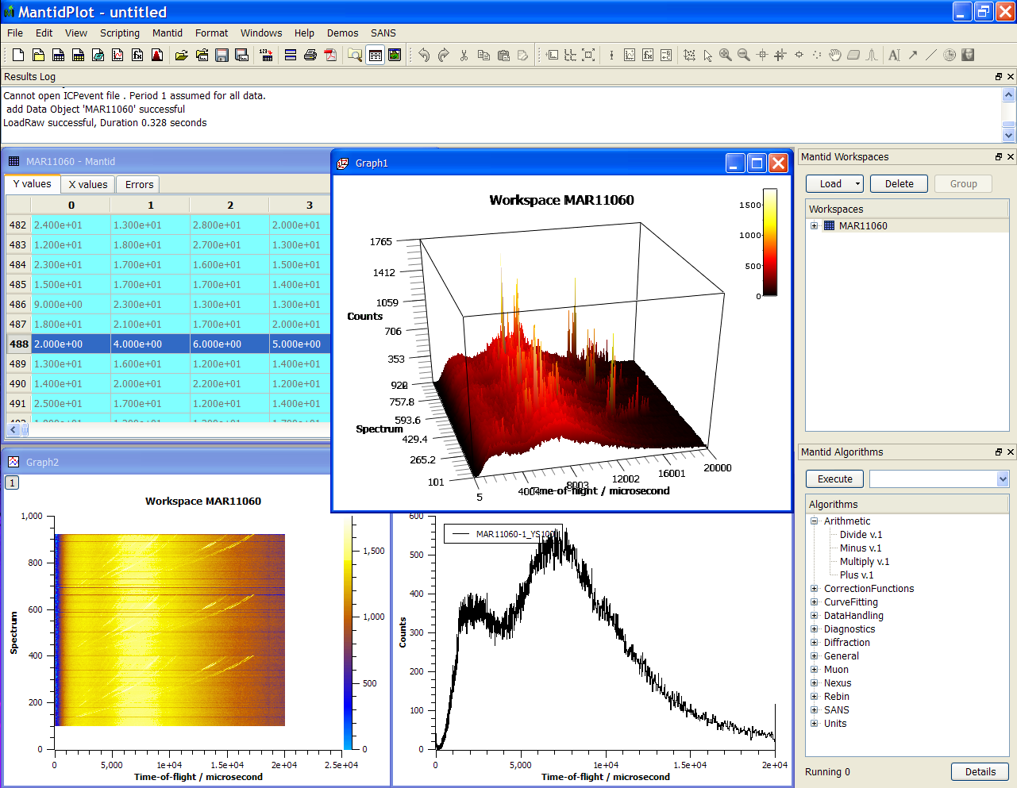
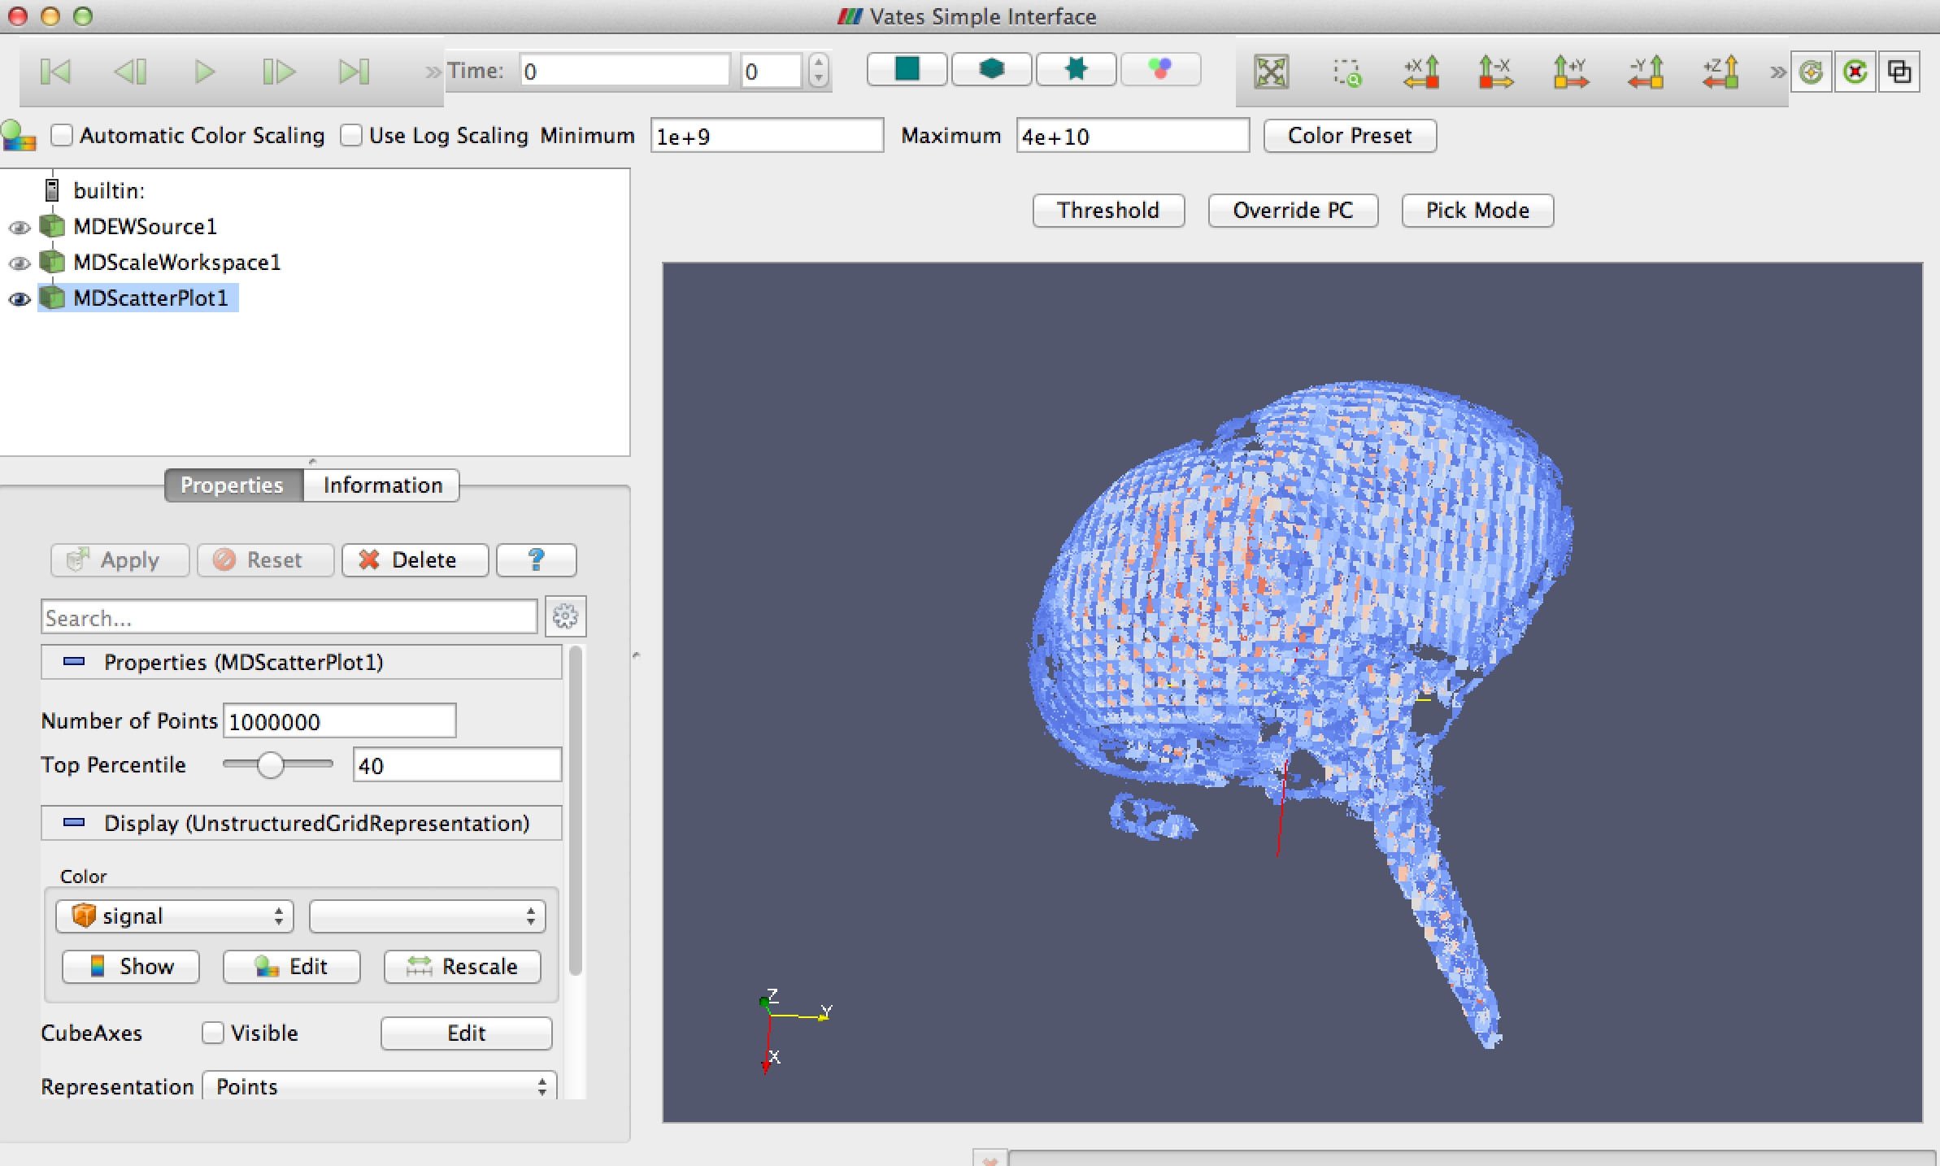
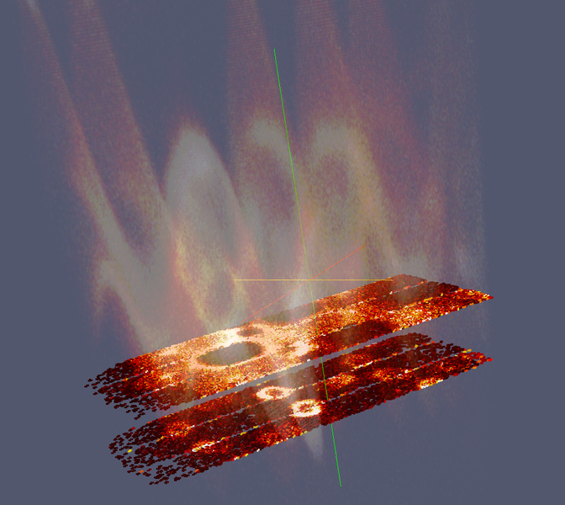
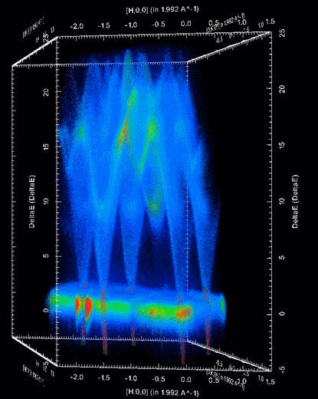

Document Control
This document is under document control. All members of the distribution list will receive updated copies whenever alterations are made. All other copies are uncontrolled.

Contributors
Name | Role | Company
Nicholas Draper | Author | Tessella

Document Approval
Name | Role | Company

Distribution
Name | Role | Company
Project Management Board Members | Recipient | STFC & ORNL
Mantid Project Repository | Filing | STFC & ORNL

Revision History
Author | Issue | Date | Description
Nicholas Draper | V1.R1.M0 | 15-Jan-2016 | 1st version written

References
Document | Ref | Date | Details and Version
Project Specification | [PS] |  | https://github.com/mantidproject/documents/blob/master/Project%20Management/ProjectSpecification.doc?raw=true
Stakeholder Plan | [SP] |  | https://github.com/mantidproject/documents/blob/master/Project%20Management/StakeholderPlan.doc?raw=true
Risk Register | [RR] |  | https://github.com/mantidproject/documents/blob/master/Project%20Management/RiskRegister.xls

Table of Contents
1 Introduction 3
2 Minutes of the previous meeting 4
3 Project Documentation 4
4 Project Status 4
5 Usage of Mantid in various Environments 6
6 Interest from Other Facilities 8
7 Future Release Dates 8
8 Appendix A: Metrics 10

Introduction

Purpose of this Document
This report details the current state of the Mantid project and presents the agreed agenda for discussion. The project management board will use the information in this report as a basis for the meeting.

Scope of this Document
The scope of this document is limited to the Mantid project, both for progress up to the meeting of the Project management board, and plans for the future.

Context of this Issue
This is the seventeenth project management report to the Mantid project management board and will provide input to the meeting.

Minutes of the previous meeting
The minutes of the previous meeting are available here:
https://github.com/mantidproject/documents/blob/master/Project-Management/PMB/Minutes/PMBMinutes29thMay15.docx?raw=true

Project Documentation
The project documentation is available through the links below. The documents have not been changed since the last PMB meeting.

Stakeholder Plan:
https://github.com/mantidproject/documents/blob/master/Project%20Management/Stakeholder Map.doc?raw=true
No changes this time

Risk Register:
https://github.com/mantidproject/documents/raw/master/Project-Management/RiskRegister.xls

Reviewed, One new risk associated with the ISIS in kind team for the ESS:
Ref No. | Description of Risk |  | Impact | Probability |  | Rating | Current Controls in place | Effectiveness  of Mitigating  Action | Overall Rating
36 | Insufficient support from ESS computing group | Significant |  | Very likely | 16 |  | Wider DMSC meetings | Satisfactory |  | MEDIUM 16

Project Status

Development Progress
Since the last PMB meeting in January 2015 we have not release any new version of Mantid, but version 3.6 is undergoing beta testing and is planned for release on the 15th of February.
The project metrics in Appendix A.

Update on progress of SSC requirements

Completed in Release 3.5
id | summary | status | owner
#12172 | Add Note | closed | Elliot Oram
#12074 | Enhancment for Vesuvio | closed | Martyn Gigg
#12069 | Documentation/Consistency for input parameters e.g. workspace index vs spectrum number | closed | Nick Draper
#12064 | Check Mantid Version on Startup | closed | Nick Draper
#10149 | Tools to help compare models to data | closed | Roman Tolchenov
#6457 | SANS: Assess & rectify zero errors in ISIS SANS data | closed | Anton Piccardo-Selg

Usage of Mantid in various Environments
We currently fully support the following environments:
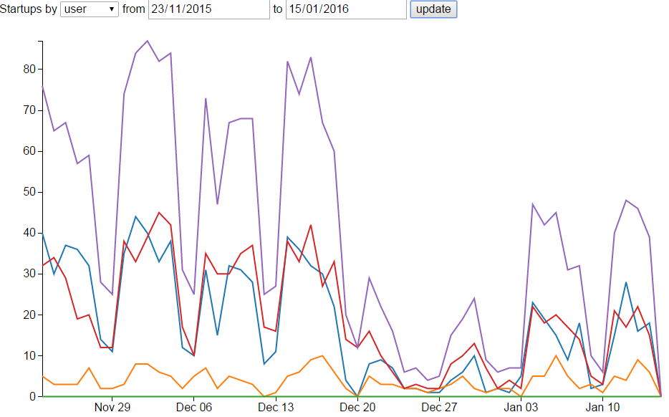
- RHEL 6 64bit
Total
Linux
Windows
Mac
- RHEL 7 64bit
- Windows 7 64 bit
- Ubuntu LTS 64 bit
- OS X 10.9 Mavericks+
Limited Support:
Windows 8 64 bit
Fedora 20

No support – but apparently works:
Windows 10

Current Usage:
http://reports.mantidproject.org/
Looking since the last PMB we have a similar number of active Linux and windows users running Mantid, around 40 per day on a normal weekday during cycle and about 20 per day outside of cycle. The number of Macs is much lower with a peak of about 10 per day, and does not seem to be affected by operational cycles.
These numbers are not affected by the development team or the build and test servers.

Operating System Usage:
Operating System | 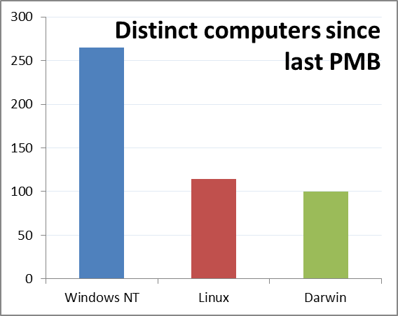  count(distinct host)
Microsoft Windows 7 Professional | 115
Microsoft Windows 7 Enterprise | 66
Mac OS 10.10. | 48
Red Hat Enterprise Linux Workstation 7.2 (Maipo) | 36
Mac OS 10.11. | 35
Red Hat Enterprise Linux Server release 6.6 (Santi... | 33
Microsoft Windows 8.1 | 17
Microsoft Windows 10 Home | 16
Microsoft Windows 7 Home Premium | 16
Mac OS 10.9. | 13
Ubuntu 14.04.3 LTS | 11
Microsoft Windows 10 Pro | 9
Microsoft Windows 8.1 Pro | 9
Red Hat Enterprise Linux Workstation 7.1 (Maipo) | 9
Mac OS 10.1 | 7
Microsoft Windows 7 Ultimate | 4
Red Hat Enterprise Linux | 4
Red Hat Enterprise Linux Workstation release 6.5 (... | 4
Ubuntu 14.04.2 LTS | 3
Microsoft Windows 8.1 Single Language | 3
Scientific Linux release 6.0 (Carbon) | 2
Debian GNU/Linux 8 (jessie) | 2
Ubuntu 15.04 | 2
Ubuntu 15.10 | 2
Red Hat Enterprise Linux Workstation release 6.6 (... | 2
Red Hat Enterprise Linux Workstation release 6.7 (... | 1
Arch Linux | 1
Scientific Linux 7.1 (Nitrogen) | 1
CentOS Linux 7 (Core) | 1

Algorithm Usage:
As of version 3.6 we have introduced the ability to track the number of times each algorithm is used for each version of Mantid. This will allow us to identify:
- Algorithms that are heavily used and therefore need extra care taken over any changes.
- Algorithms that are never used, and may possibly be removed to simplify Mantid.
- Similar algorithms that are candidate for merging.

Interest from Other Facilities

ILL
Mark Johnson has advertised for 3 developers to work on Mantid, is interviewing at the start of February, I am travelling to the ILL to help with the interviews, and is planning on starting the team up towards the end of Q1 2016.

Joint European Torus
I have been approached by Alys Brett the head of data systems and tools for the JET nuclear fusion experiment. They are exploring options for the future of our visualisation tools for the various aspects of the JET experiments, wanting to move on from a collection of legacy codes to something more integrated.
I have visited them for an initial chat, and there is fairly good similarity about the structures of their data to our workspace approach at a high level, and they really liked many of our visualization tools. The also see the potential to move towards making use of the data processing capabilities of Mantid in the future.
They are a team of 4 developers and if they decided to adopt Mantid as their path for the future said they would be prefer to join the collaboration rather than just make use of Mantid as an open source contributor.
There next step in the evaluation is to spend a couple of weeks extending Mantid to read and display some of their data. I have encouraged them to keep in touch with us over this, and we have discussed the possibility of a developer visiting at the start of this to set them off in the right direction.

Future Release Dates
The proposed release dates for the future are:
v3.6 15th February 2016
v3.7 6th June 2016
ISIS – Down, Restart 28th June
SNS – Down, Restart 14th July
HFIR – Down, Restart 14th June
v3.8 17th October 2016
ISIS - Beyond published facility planning calendar
SNS - Beyond published facility planning calendar
HFIR – Down, Restart 10th November
This does not include patch releases.

Appendix A: Metrics

Project Metrics
The code metrics are independently generated and displayed here
http://www.openhub.net/p/Mantid/analyses/latest/languages_summary
Total Lines : | 2,998,949 |  | Code Lines : | 2,256,044 |  | Percent Code Lines : | 75.2%
Number of Languages : | 20 |  | Total Comment Lines : | 423,764 |  | Percent Comment Lines : | 14.1%
 |  |  | Total Blank Lines : | 319,141 |  | Percent Blank Lines : | 10.6%

Code, Comments and Blank Lines
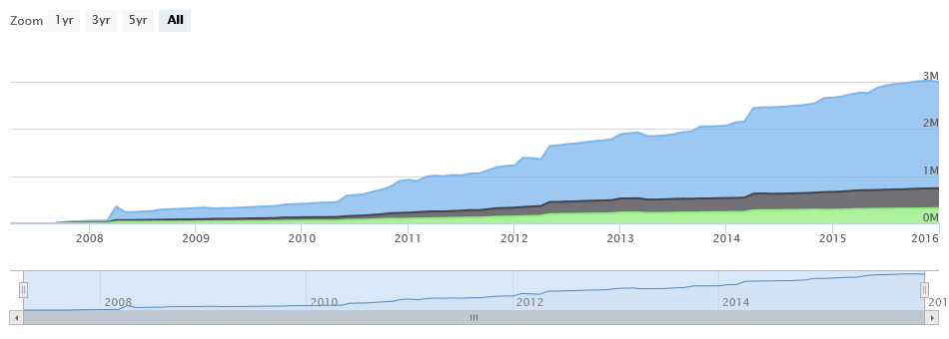
Code
Comments
Blanks

In a Nutshell, Mantid...
- has had 53,093 commits made by 108 contributors
representing 2,256,044 lines of code
- is mostly written in C++
with an average number of source code comments
- has a well established, mature codebase
maintained by a very large development team
with increasing Y-O-Y commits
- took an estimated 640 years of effort (COCOMO model)
starting with its first commit in April, 2007
ending with its most recent commit about 12 hours ago

